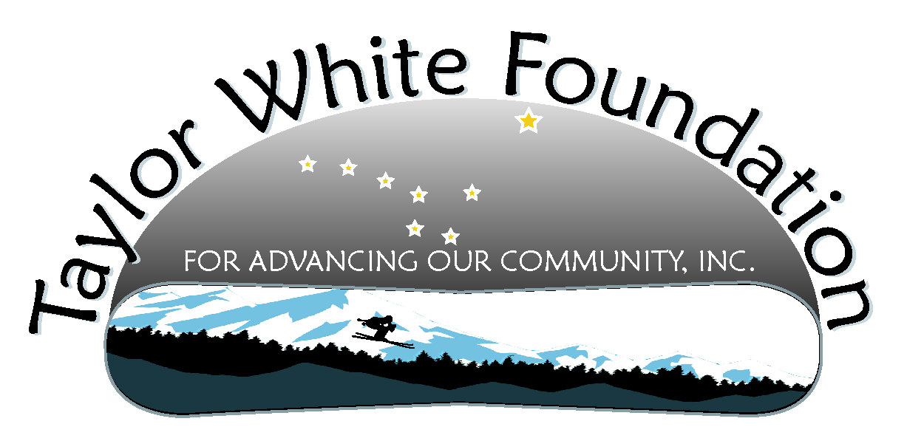
Taylor White Foundation Board Meeting
March 6, 2011

Members Present: Sam Roche, Morgan Thomas, Linda Cabello, Tyler Emerson, Kristin Bartlett, Lauree Dicarlo, Carol White, Kevin White

Item | Reporting | Action Items
- Treasurer’s Report | The Foundation has a balance of $25,414.62
- Car Display Update  - Insurance issues  - Trailer  - Display  - Next steps | The trailer is in town and stored at Gastineau Contracting. The car is currently buried under snow plowed snow. We may have to have a digging party to get it out. Sam volunteered to help Kevin with that if necessary.  The board felt it was important to have the story of kids killed in similar crashes as part of the display.  The suggesting was made to put up a sign saying drive carefully in memory of Taylor White. Lauree was going to look into that for us. | Lauree will look into how you go about getting a highway sign similar to those that say who is responsible for maintaining a stretch of the highway.
- Driver’s Training  - Project description  - Current status  - Funding opportunities  - Next steps | Reported on Kevin’s attempts to meet with SEARRC, with no success. The decision was made to begin the steps to form up a workgroup to move this project forward. Carol reported contacting SEARCH about a possible grant opportunity and that she was pursuing another grant from Allstate. | Kevin will form up a workgroup  Carol will work on grant
- Under 21 Club/Event  - Report on contact with Miguel/Alex  - Report on kids who might be interested  - Next steps | Linda reported she had met with Alex and he was interested in helping with a Under 21 Club Foundation event. Sam has also agreed to work with Linda in putting this together.  Loree has a relative that has some equipment that might be useful for the event. She was going to check to see if we could borrow it. | Linda was going to recruit 2-3 more kids, and she, Sam and Alex will meet to move this forward.  Loree will check with relative about the equipment.
- Documentary  - Web Analytics Report  - Petersburg  - Anchorage  - Juneau High Schools  - Report on conversations with middle schools | Morgan reported we are having an average of 15 visitors/day to the website -- with peaks at around 30. The video is getting about 5 plays/per day and there were 130 plays this month.  We have no definite plans for the Juneau high schools this month. Nancy Seamount has expressed interest and Kevin has had calls into her, but she has not returned any calls.  Kendra Buerger and Darby Brown sent an email letter out to all the principals in the Anchorage School District introducing the documentary and expressing their willingness to accompany the video into the schools.  Kristen offered to contact her colleague Heather to let her know of the offer.  Lauree and Kristen both have tried to contact middle school people to determine interest in the Foundation, but have yet not connected.
- Awareness  - Stickers  - Discuss Kristen’s ideas | Morgan will work on the stickers in May once school is done. Ideas on ways to use them to build awareness is to have them at the 8th grade dances which are May 20 and May 21. We could also provide door prizes, like one of the sweatshirts, and wrist bands. We can discuss in more detail next meeting
- Youth Recruitment  - Meeting next week  - Other ideas | Carol and Ulla plan to meet with Nancy Seamount and Bob Swanson about recruiting kids to help. | Carol to meet with Ulla, Nancy Seamount and Bob Swanson about recruiting kids to help.
- For the good of the order – March 9 Community Health | Carol and Linda plan to attend
- Next meeting | April 3, 4:30-6:00

